NWEA Test - Class Average
Fall Test -Grade 4
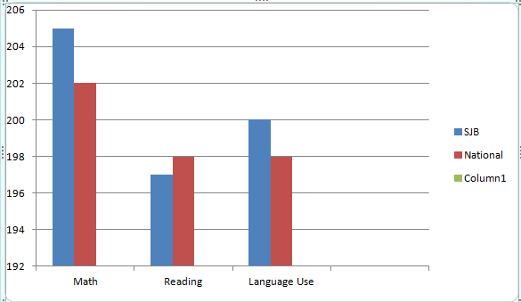
Spring Test - Grade 4
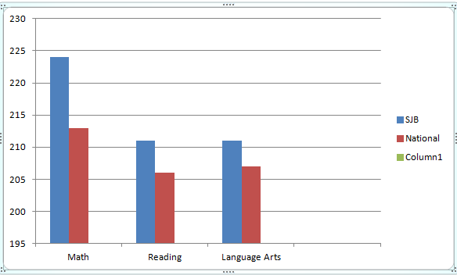

 | Fall |  |  | Spring
 | SJB | National | Difference | SJB | National | Difference
Math | 205 | 202 | +3 | 224 | 213 | +11
Reading | 197 | 198 | -1 | 211 | 206 | +5
Language Arts | 200 | 198 | +2 | 211 | 207 | +4

