Fourth Grade News Letter From Sister Navya’s Classroom (4/23 – 4/26)
http://grade4-sjbschool.weebly.com sr.navya@sjb-school.org
Language Arts:  This week we will be reading narrative nonfiction.  Students will  -determine the main idea of a text and explain how it is supported by key details; summarize the text  -use common, grade-appropriate Greek and Latin affixes and roots as clues to the meaning of a word  -use context as a clue to the meaning of a word or phrase. | Dates to Remember in  April  4/ 26 – Hot lunch, Poetry pause  Bible Verse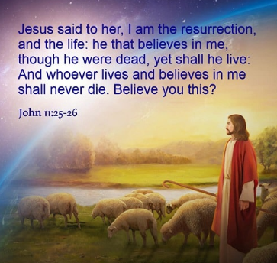  Reminders:  This week I am going to introduce our Personal Safety Curriculum - Protecting God's Children.  Wednesday – NWEA practice test  Friday – spelling test, poetry pause | 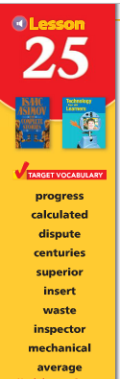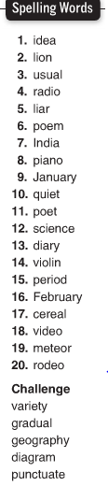  Spelling test on Friday  4/26/2019
Math -
Students will
- -learn how to find the area of a circle
- find the volume of a rectangular prism
-multiply fractions
-multiply and divide decimal numbers by powers of ten

Social Studies – The Southwest
Students will:-understand cultural diversity in Texas and Oklahoma
-describe the growing economy of Arizona and New Mexico
- make slides for State presentation

Science:
Students will
-describe how the skeletal system works
-describe how the muscular system works

Religion - Protecting God’s Children
Personal Safety Curriculum - “Teaching Boundaries and safety” lessons.

