Fourth Grade News Letter From Sister Navya’s Classroom (4/1 – 4/5)
http://grade4-sjbschool.weebly.com sr.navya@sjb-school.org
Language Arts:  This week we will be reading a biography.  Students will  -tell how events are related and how one event causes another  -use text clues to figure out what isn’t directly stated by the author | Dates to Remember in  April  4/4 – Holy Mass (Gr.4)  4/6 – Library  4/11 – Report cards go home  4/12 – Lenten retreat  4/19 – Good Friday ( No School)  4/ 22 – Easter Monday ( No School)  4/ 26 – Hot lunch, Poetry pause  Stations of the Cross on Mondays at 3:00 P.M.  Bible Verse  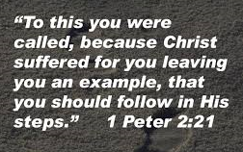  Reminders:  Monday: Homework – get ready for social studies test (chapter 8, pages 246-269) and do the study guide.  Friday: spelling test | 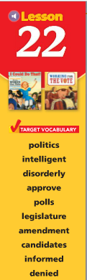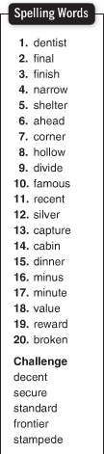  Spelling test on Friday  4/5/2019
Math - Decimals

Students will:
-round decimal numbers
- estimate decimal sums and differences
-add and subtract decimals
-measure the perimeter of polygons

Social Studies

Students will:
-identify the ethnic groups and cultures of the Great Lake States
-describe the economy of the Great Lake States

Science: How Our Body Works
Religion - The sacrament of Reconciliation

Students will:
-identify the two Sacraments of Healing
-explain the importance of sacrament of Reconciliation
-review the steps for the Sacrament of Reconciliation
-learn about St. John Vianney

